Chapter 9:
NOTE: IN THE EFFORT OF SAVING TIME PRE EXAM, I’M ONLY PUTTING WHAT I THINK YANG IS GETTING AT FOR EACH POINT. IF YOU WANT A FULL RECAP, VIEW THE WEEK11-2 and WEEK12 ppts
○ Quality review / risk management

a. Review metrics
• 2-3 terms with a simple calculation
• Error density
• Effort saved

Glossary:
- Preparation effort, E_{p} —the effort (in person-hours) required to review a work product prior to the actual review.
- Assessment effort, E_{a} — the effort (in person-hours) that is expended during the actual review.
- Rework effort, E_{r} — the effort (in person-hours) that is dedicated to the correction of those errors uncovered during the review.
- Work product size, WPS —a measure of the size of the work product that has been reviewed (e.g., the number of UML models, or the number of document pages, or the number of lines of code)
- Minor errors found, Err_{minor} —the number of errors found that can be categorized as minor (requiring less than some prespecified effort to correct)
- Major errors found, Err_{major} —the number of errors found that can be categorized as major (requiring more than some prespecified effort to correct)
Main calcs:
E_{review} = E_{p} + E_{a} + E_{r}
Err_{total} = Err_{minor} + Err_{major}
Error density = $\frac{Errtotal}{WPS}$
Effort saved per error = E_{testing} – E_{reviews}

Error density examples:
If the average error density for a req. model is 0.6 errors per page, and a new requirement model is 32 pages long, your software team will find about 19 or 20 errors during the review of the document. If you find under 19 by a significant margin (i.e. only 6 errors), you’ve done very well OR your review was ass.

A requirements model contains 18 UML diagrams as part of 32 overall pages of descriptive materials. The review uncovers 18 minor errors and 4 major errors.
Therefore, Err_{tot} = 22.
Error density is 1.2 errors per UML diagram (22 / 18) or 0.68 errors per requirements model page (22 / 32).

Effort saved example
Effort saved => assume E_{testing} = 45 person-hours per error, E_{reviews} = 6 person-hours per error
Effort saved per error = E_{testing} – E_{reviews} = 30 person-hours per error
NOTE: I know 45-6 is not 30, but Yang doesn’t. Carry on

Since 22 errors were found during the review of the requirements model, a saving of about 660 person-hours of testing effort would be achieved. And that’s just for requirements-related errors. Errors associated with design and code would add to the overall benefit. The bottom line—effort saved leads to shorter delivery cycles and improved time to market.

b. Software quality analysis
• Being tested with Real examples
c. Software process, evaluate (ppt)
• Product
• People
• Technique
d. Risk projection
• "Simple discussion"
Risk always involves two characteristics: uncertainty — the probability the risk may or may not happen 1 —and loss —if the risk becomes a reality, what unwanted consequences or losses will occur. When risks are analyzed, it is important to quantify the level of uncertainty and the degree of loss associated with each risk.
Types of Risks:
- Project risks threaten the project plan. If project risks become real, the project schedule will likely slip and costs will increase.
- Technical risks threaten the quality and timeliness of the software to be produced.
- Business risks threaten the viability of the software to be built and often jeopardize the project or the product.
- Known risks are those that can be uncovered after careful evaluation of the project plan, the business and technical environment, and/or other reliable information sources
- Predictable risks are extrapolated from past project experience
- Unpredictable risks are unpredictable, and extremely difficult to identify in advance.
Risk Projection:
Risk projection / estimation attempts to rate each risk in two ways—(1) the likelihood or probability that the risk is real and will occur and (2) the consequences of the problems associated with the risk, should it occur.
Four steps:
- 1. Establish a scale that reflects the perceived likelihood of a risk.
- 2. Delineate the consequences of the risk.
- 3. Estimate the impact of the risk on the project and the product.
- 4. Assess the overall accuracy of the risk projection so that there will be no misunderstandings.
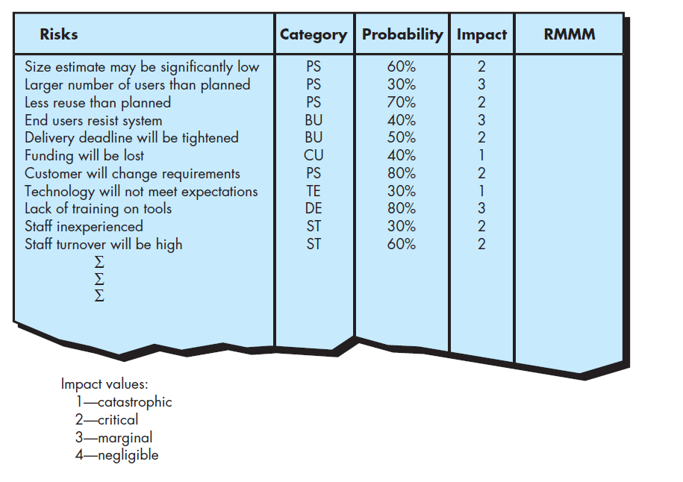
Figure 1(e.g., PS implies a project size risk, BU implies a business risk)
RMMM – risk mitigation, monitoring and management
More details on it in week12 slide, but basically, do the stuff in here:
